FORM – 2

THE PATENTS ACT, 1970

(39 of 1970)

COMPLETE SPECIFICATION

(Section 10, rule 13)

**Speech Therapy Assessment Application**

**NAME OF APPLICANTS:**

Chirag Chewade-22010070

Harsh Chawla-22010826

Niraj Amrutkar22010910

Suniket Khairnar-22010917

**Residing at**

**FIELD OF THE INVENTION:**

The present invention pertains to a client-server mobile application specifically crafted for enhancing the diagnosis and therapeutic intervention processes for individuals diagnosed with autism spectrum disorder (ASD). It operates within the realm of healthcare technology, with a focus on improving the collaboration between healthcare professionals and ASD patients.

**BACKGROUND OF THE INVENTION:**

The background of the invention lies in the complex landscape of Autism Spectrum Disorder (ASD), a neurodevelopmental condition characterized by challenges in social interaction, communication, and repetitive behaviors. The rising prevalence of ASD underscores the critical need for innovative and accessible interventions to support individuals diagnosed with this disorder. Traditional methods of diagnosis and therapeutic interventions often fall short in providing the necessary interactive and personalized elements essential for engaging individuals with ASD effectively.

The proposed client-server mobile application emerges as a response to the challenges faced by healthcare professionals, particularly doctors, in efficiently diagnosing and intervening in ASD. The background of the invention recognizes that current approaches lack the dynamic and personalized elements crucial for fostering engagement and skill development in individuals with ASD. Leveraging a client-server architecture, the application seeks to create a collaborative platform that not only streamlines the diagnostic journey but also facilitates targeted and personalized therapeutic interventions.

In essence, the background of the invention underscores the urgency of addressing the multifaceted challenges in ASD interventions and highlights the potential of technology to contribute significantly to the evolving landscape of healthcare practices for individuals with ASD. The application's focus on personalization, collaboration, and accessibility positions it as a promising solution to enhance the overall care provided to individuals diagnosed with Autism Spectrum Disorder or any other speaking difficulties.

**PRIOR ART:**

Traditional approaches to Autism Spectrum Disorder (ASD) interventions have primarily involved manual and paper-based diagnostic methods, often lacking the dynamism and personalization required for engaging individuals effectively. The existing landscape comprises various tools and techniques, yet they tend to fall short in seamlessly connecting healthcare professionals and patients, particularly children with ASD. Conventional diagnostic tools, such as standardized assessments and paper-based exercises, lack the technological advancements necessary to cater to the diverse and evolving needs of individuals with ASD.

Moreover, previous interventions may not fully harness the potential of multimedia elements and real-time collaboration features. The prior art demonstrates a gap in providing a comprehensive and interactive platform for healthcare professionals and individuals with ASD to collaborate effectively. Current solutions may not leverage the capabilities of modern technology to create an engaging and personalized environment, limiting their effectiveness in enhancing the diagnostic and therapeutic processes.

According to prior art, there is a need to develop a mobile application seeks to address these gaps by integrating cutting-edge technologies, personalized practice cards, multimedia assessments, and secure parent monitoring, thus presenting a novel and innovative approach to ASD interventions.

**OBJECTIVES OF THE INVENTION:**

The primary objective of the invention is to provide a technologically advanced and user-friendly platform for healthcare professionals and individuals with ASD. By leveraging a client-server architecture, the application aims to bridge existing gaps in the diagnostic and therapeutic processes. The overarching goal is to enhance engagement, improve diagnostic accuracy, and contribute to the overall well-being and skill development of individuals with ASD.

**SUMMARY OF INVENTION:**

The invention comprises a client-server mobile application designed to operate seamlessly within clinical settings. Healthcare professionals, acting as administrators, utilize the application to study patients, assign personalized practice cards tailored to specific skill development needs, and conduct multimedia-enhanced assessments. Patients, on the client-side interface, interact with the assigned cards and participate in assessments, creating an engaging and interactive platform for skill development and intervention.

**DETAILED DESCRIPTION OF THE INVENTION:**

##### The present invention constitutes a dual-purpose system designed to address the specific needs of children diagnosed with Autism Spectrum Disorder (ASD) in the context of speech therapy. This innovative system operates with a dual module structure, featuring an administrative module and a user module, thereby catering to both healthcare professionals and end-users. The primary objective is to provide essential support to children with ASD while facilitating effective progress monitoring by healthcare professionals.

##### 1.System Architecture and Functionality:

##### The invention operates as a sophisticated and integrated system, establishing seamless communication with a database for the secure storage of user data. The administrative module is instrumental in granting authorized users, such as healthcare professionals, the capability to manage therapy content. This includes tasks like adding, modifying any language-specific speech therapy materials and assessment questions. On the other hand, the user module is tailored to offer a user-friendly interface to children and their parents, enabling them to actively participate in speech therapy exercises, listen to audio pronunciations, and undergo assessments to monitor progress.

##### 2.User Authentication and Roles:

##### The system incorporates a robust user authentication mechanism with two main user types: administrators (admins) and regular users. Admins possess additional privileges for managing the system, while regular users, typically parents or caregivers, can access therapy content and track their child's progress.

##### 2.1 Admin Module:

##### Content Management: Admins have the capability to manage therapy content, including the creation and editing of therapy material categories and individual therapy cards within those categories. Each card includes an image representing the therapy concept and audio pronunciation in Marathi.

##### Assessment Management: Admins can set up assessments for users, defining specific cards or categories to be included in each assessment, aiding in tracking a child's progress over time.

##### 2.2 User Module:

##### User Dashboard: Upon logging in, regular users are presented with a user-friendly dashboard where they can access various features of the application.

##### Category Selection: Users can select specific therapy categories to work on during their therapy sessions, such as Marathi Alphabets, Sentences, or Words.

##### Audio Pronunciation: Users can listen to audio pronunciations associated with each therapy concept, facilitating correct pronunciation understanding.

##### Assessments: Users can take assessments based on the content selected by the admin, providing valuable feedback on the child's development.

In summary, the proposed speech therapy application represents a comprehensive and technologically advanced solution tailored to the unique needs of children diagnosed with ASD. By addressing speech and language development challenges through a dual-module system, the invention aims to revolutionize how healthcare professionals and caregivers collaborate in providing effective speech therapy.

|  |  |
| --- | --- |
|  |  |
|  |  |

**CLAIMS:**

We claim,

1. A client-server mobile application for ASD intervention, comprising a client-side interface for patients, a server-side interface for healthcare professionals, and a centralized dashboard for managing patient data.

2. The application of claim 1, wherein personalized practice cards are dynamically assigned to patients based on specific skill development needs.

3. The application of claim 1, further comprising multimedia-enhanced assessments utilizing a combination of visual and auditory stimuli to facilitate comprehensive skill evaluation.

|  |  |
| --- | --- |
|  |  |
|  |  |

**Speech Therapy Assessment Application**

**ABSTRACT**

This research explores the development and implementation of a client-server mobile application designed to facilitate the diagnosis and therapeutic intervention for individuals with autism spectrum disorder (ASD). The application serves as a collaborative platform connecting healthcare professionals (doctors) and their patients, streamlining the diagnostic process, therapeutic assignment, and progress monitoring. The app operates on a client-server architecture, where doctors, serving as administrators, study patients within clinical settings. The research delves into the technical aspects of the app, incorporating technologies such as Cloudinary for multimedia management, SQL for database functionality, and React Native for cross-platform mobile development. Methodology includes a comprehensive exploration of the system design, implementation details, and user feedback.

FIGURE 1

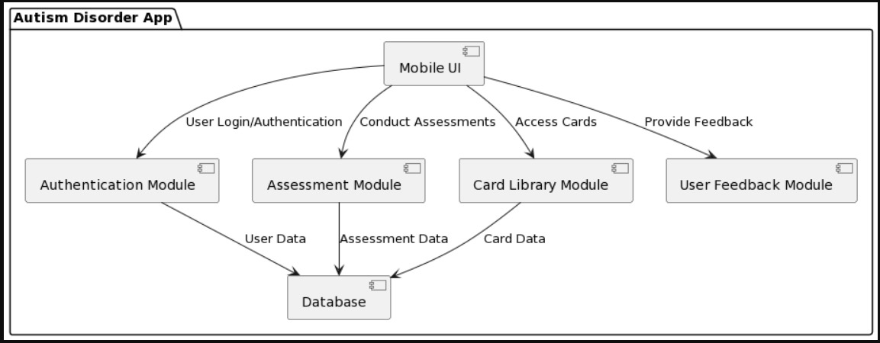

FIGURE 2

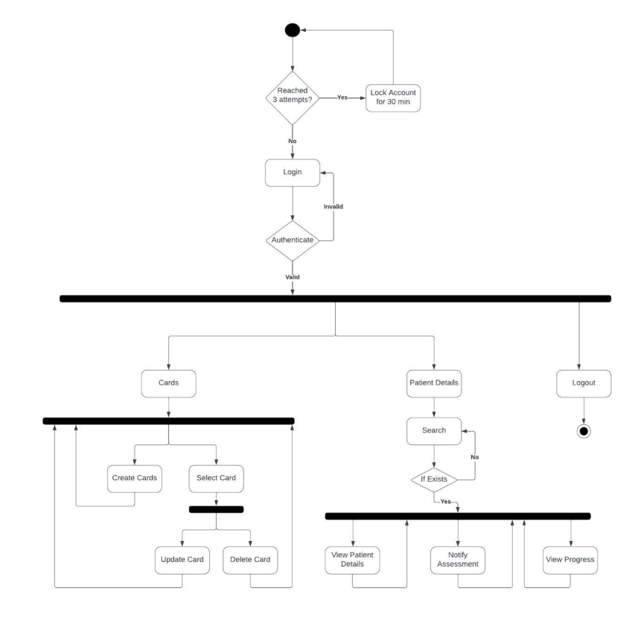

FIGURE 3

|  |  |
| --- | --- |
|  |  |